**Practical No - 9**

**Aim**: Data Pre Processing

**Solution:** Only the first tab, ‘Preprocess’, is active at the moment because there is no dataset open.

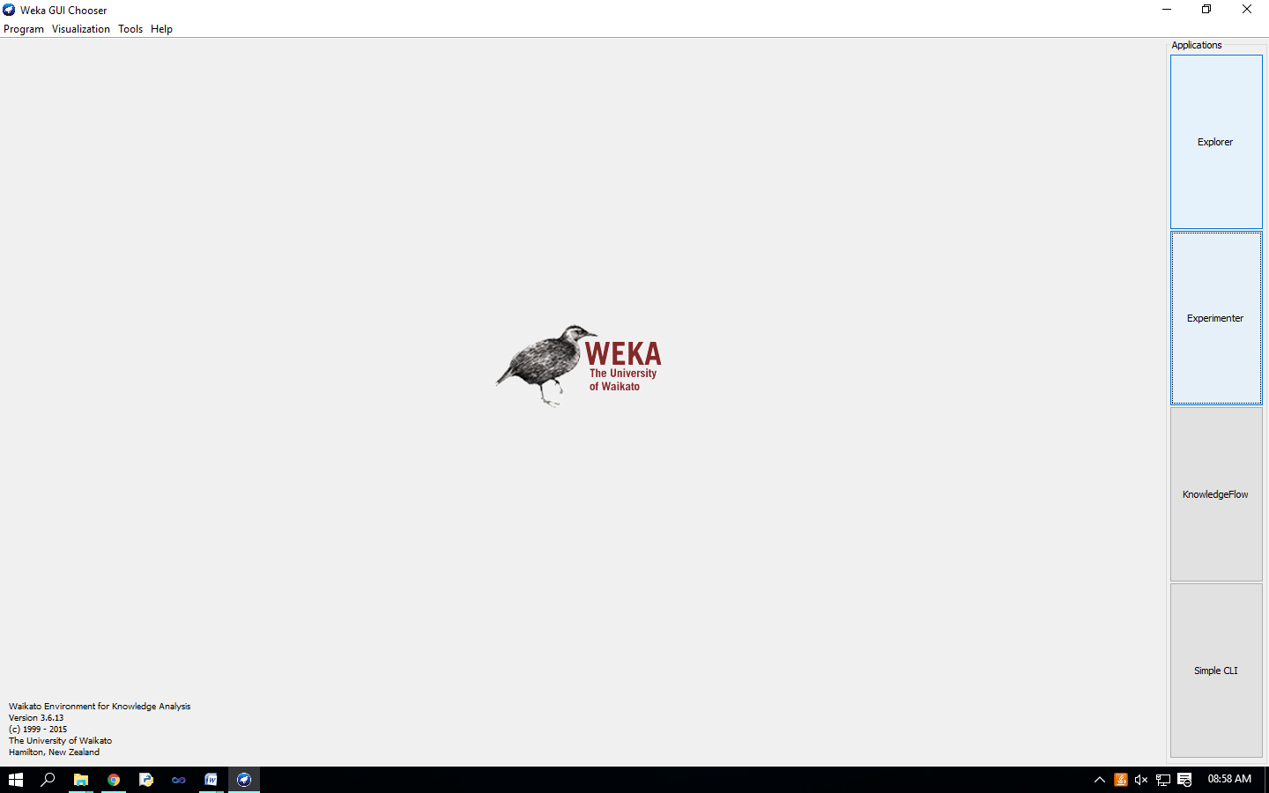

Opening file from a local file system Click on ‘Open file…’ button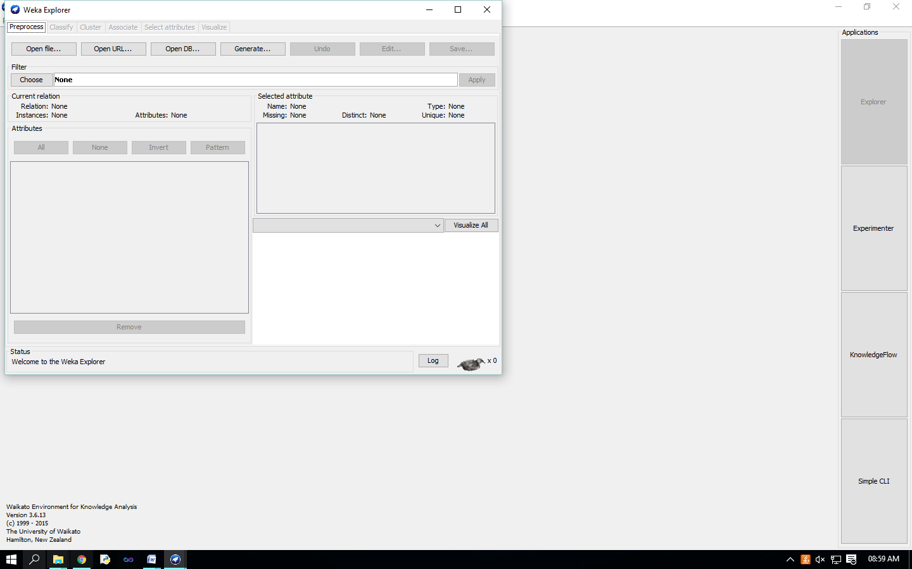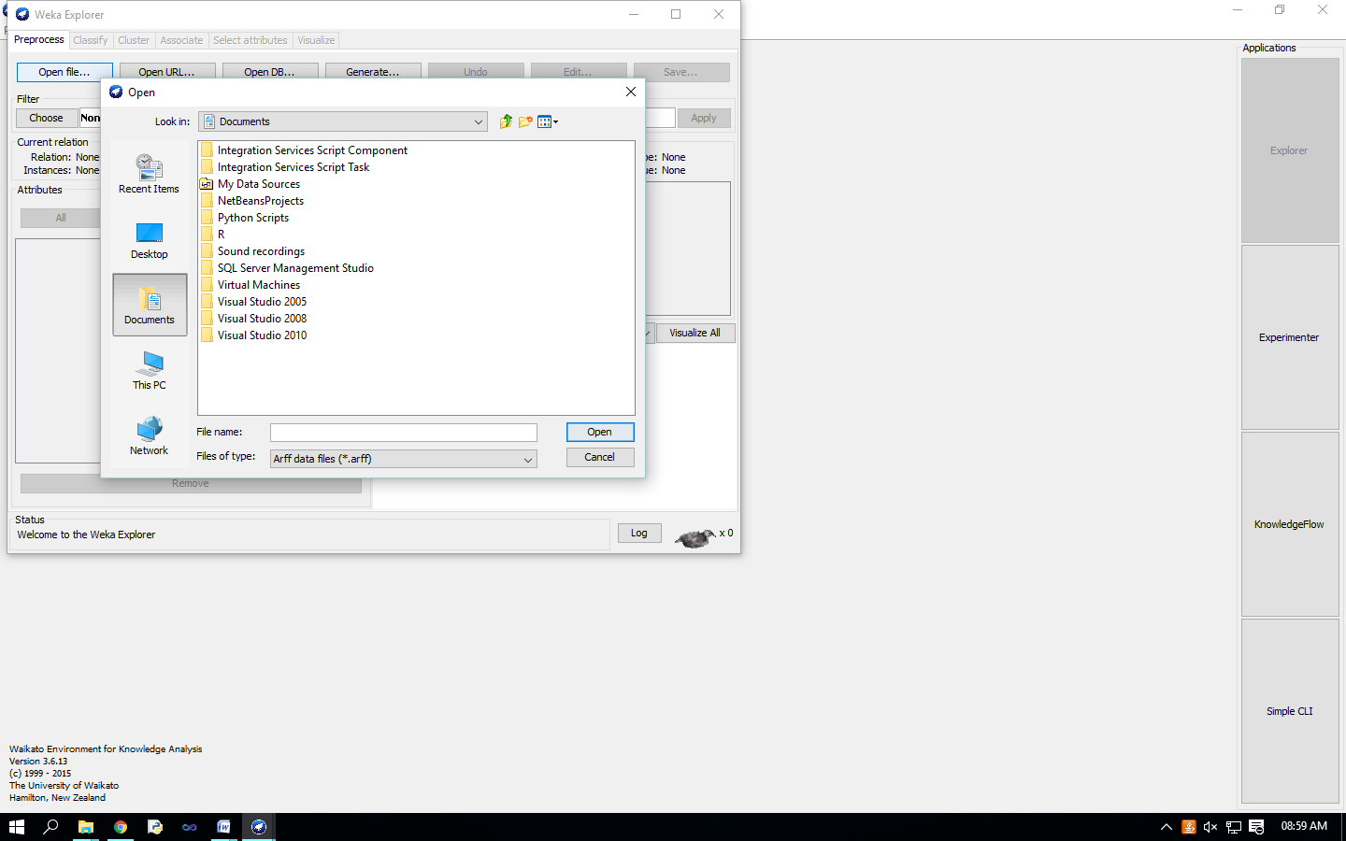

It brings up a dialog box allowing you to browse for the data file on the local file system, choose “weather.arff” file.

C:\Program Files (x86)\Weka-3-6\data

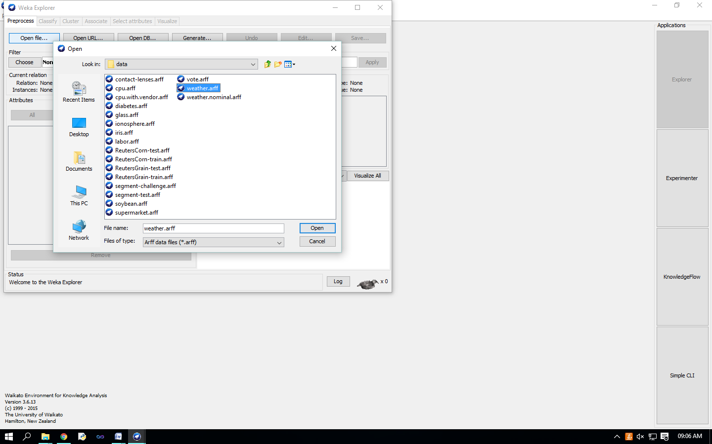

Loading data The most common and easiest way of loading data into WEKA is from ARFF file, using Open File button. 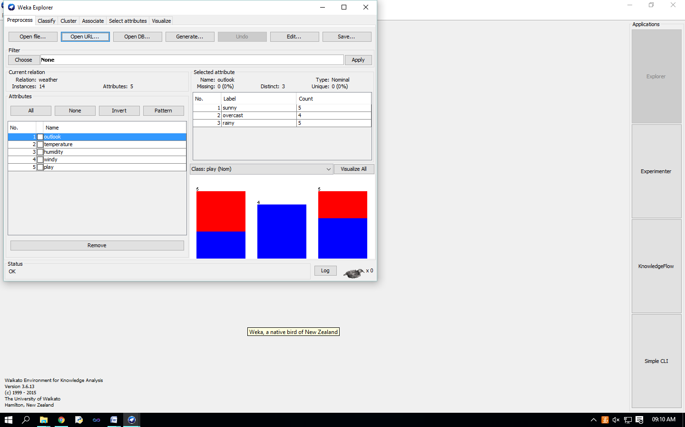 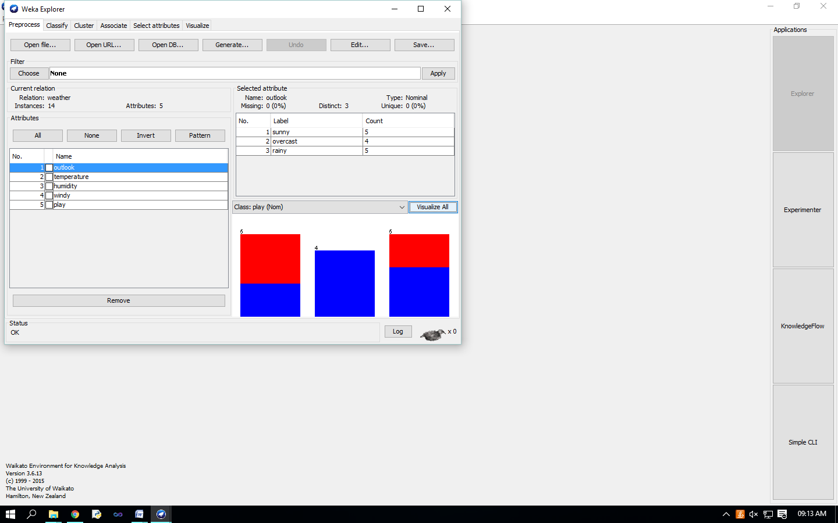

Visualize Attributes: 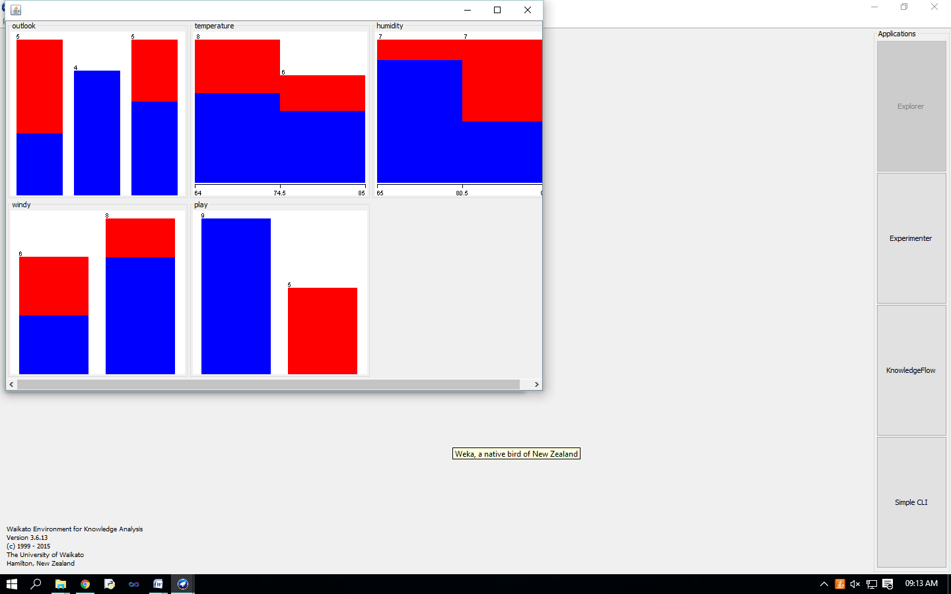

visualize all attributes by clicking on ‘Visualize All’ button.,